Introduction to particle physics

A brief history of the discovery of the structure of matter

Cormac O’Raifeartaigh PhD

Waterford Institute of Technology

Prologue 3

I The atomic theory

The Greek atom, the chemistry of the elements, Kinetic theory, Brownian motion 4

II Early particles

Cathode rays and the electron, canal rays and the proton

III The nuclear atom 5

The plum pudding atom, Rutherford’s nuclear atom

IV Nuclear physics

Transmutation, the neutron, radioactivity, nuclear fission and fusion

Interlude: quantum theory and particle physics

V Cosmic rays, the weak force and the strong force 8

The neutrino, the pion and the muon

VI Accelerators and the particle zoo 9

Accelerators, strange particles, resonances

Interlude: the forces of nature

VII The quark model of particle physics 12

The eightfold way, the search for quarks and leptons

VIII The electroweak interaction

IX The standard model 14

The electro-weak interaction, quantum chromodynamics

X The search for the Higgs boson

XI Beyond the standard model

Grand unified theory, unified field theory, string theory

Supersymmetry, supergravity and superstrings 15

Epilogue 16

Unified field theory and the Big Bang

I The atomic theory

1.The Greek atom

Thales (585 BC): (i) all substances can be classified as solid, liqid or gas

- water exists in all 3 forms

→ is all matter made up of water?

Thale’s followers: matter made up of 4 fundamental elements

→ earth, fire, air and water

Democritus (~350 BC): matter made up from small, indivisible particles

atoms

Example:
What happens if a piece of metal is cut into smaller and smaller pieces?
Ans: if matter is continuous, piece is infinitely divisible

Democritus: at some stage reach immutable atoms (indivisible)

Epicurus of Samos (342-270BC): expanded idea of atomism

Snag: atomism disputed by Plato and Aristotle

matter continuous, made up of four elementary principles

hotness, coldness, dryness and wetness
2. Chemistry and the elements

Many ideas from Greek philosophy adopted and spread by the Romans
Greco-Roman culture

The fall of Greek and Roman civilisations – 200 AD
The Dark Ages

Loss of knowledge
Some preserved by Islamic scholars

Re-introduced to Europe by the Moors in Spain
The Moorish conquest

The Renaissance (12th century – 15th)
Rediscovery of ancient knowledge

The Scientific Revolution (13th, 14th century)
Challenging ancient knowledge

Copernicus, Kepler, Galileo
The heliocentric universe

The Royal Society
Hooke, Boyle, Halley and Newton: the scientific method

Robert Boyle
The father of chemistry - gas laws
Could gases be made up of many corpuscules?

Lavoisier (1734-1794): observations on combustion suggested that matter comprised discrete elements, and that matter was conserved in chemical reactions

- the chemical elements hydrogen, oxygen, carbon, sodium etc

J.L.Proust (1799): study of chemical reactions

- variety of substances could be formed by combining different
quantities of the chemical elements

Law of definite proportions: “in every sample of a compound substance, the proportions by weight of the constituent elements are always the same”

John Dalton (1804): concept of atomic weight

- importance of the relative weights of atoms in obtaining
the composition of other substances

Law of multiple proportions: “if substance A combines with substance B in two or more ways forming substances C and D, then if mass A is held constant, the masses of B in the various products will be related in proportions that are the ratios of small integers”

Conclude: when elementary substances combine, they do so as discrete entities or atoms

Dalton’s atomic theory of matter

“every element composed of atoms that are physically and
chemically identical - atoms of different elements differ”

Gay Lussac (1808): “if gas A combines with gas B to form C,
the ratios of the volumes of A,B and C will be in integers”

- again implies that substances participate in reactions in discrete or corpuscular amounts

Avogadro (1811): correlated work of Dalton and Gay-Lussac

Postulated the existence of elementary molecules as the smallest particles that can make up compounds

Postulated Avogadro’s Law: “at equal temp and press, equal volumes of
gases contain equal numbers of molecules”

Snag (1850s): atomic theory under threat due to inconsistent masses

Cannizzaro (1858): inconsistent results for atomic masses due to confusion of atomic and molecular masses

- views accepted at international conference on atomic masses (Karlsruhe, 1860)

- fundamentals of modern chemistry laid

- relative atomic weights could be calculated (Avogadro’s law)

Dimitri Mendeleev (1869): Periodic Table of the Elements

Listing the chemical elements from the lightest (hydrogen) to the heaviest (uranium) caused elements with similar chemical properties to recur at regular intervals

gaps - unknown elements with predicted properties

- these elements soon discovered

Implications of Periodic Table for atomic theory

→ elements not truly independent

→ relation between atoms of different elements?

→ atoms not fundamental?

→ inner atomic structure?

3. Kinetic theory of gases

Boyle, Charles: pV = nRT (Ideal gas law)

(empirical, macroscopic)

Can this law be derived by assuming a gas comprise large numbers of molecules in constant random motion?

Maxwell, Boltzmann, Gibbs (1850-1900):

mechanics of molecular motion in gases (kinetic theory)

Boltzmann: root mean square speed of molecules
Maxwell: distribution of molecular speeds
Gibbs: mean free path of molecule

Result: ideal gas law can be derived from atomic theory

→ gases comprise large numbers of atoms in constant motion?

Experimental clue

Robert Brown (1827): random motion of pollen grains in water

motion due to collisions with water molecules?
molecules in gases and liquids in constant motion?

4. Brownian motion

Albert Einstein (PhD, 1902-05): suspensions in liquids

  - applied kinetic theory to particles in liquids
  - derived expression for diffusion constant D
  - used expression to estimate size of water molecule
  - used expression to estimate Avogadro’s number N

$$D= \frac{RT}{N}.\frac{1}{6πμP}$$

Good agreement with estimates of N by other means

Albert Einstein (1905): ‘Brownian motion paper’

  - derived expression for mean displacement of particle λ
  - statistical mechanics
  - relation between λ , D and t
  - simplified calculation to 1dimension

$<$(Δx)²$>$ = 2Dt

$λ= \sqrt{2Dt}$

But
$D= \frac{RT}{N}.\frac{1}{6πμP}$

$λ=\sqrt{t}\sqrt{\frac{RT}{N}\frac{1}{3πkP}}$

Clear prediction that could be tested experimentally

Experimental confirmation of Einstein’s formula

R. Sedding (1908): displacement & inverse viscosity

V. Henri (1908): displacement & $\sqrt{t}$

T. Svedberg (1912): displacement & $\sqrt{t}$

Initial experiments error-prone due to very small particles used

Perrin, Chaudesaigues, Dabrowski (1908-09):

Comprehensive experiments on Brownian motion

- gamboge particles in water
- large enough to be seen with microscope
- small enough to be influenced by molecular collision

- uniform size and mass
- measurements at constant temperature

Results
- mean free path proportional to $\sqrt{t}$
- predicted N in agreement with other estimates

Support for atomic hypothesis!

small particles suspended in a liquid move about as
predicted by the kinetic theory of molecules
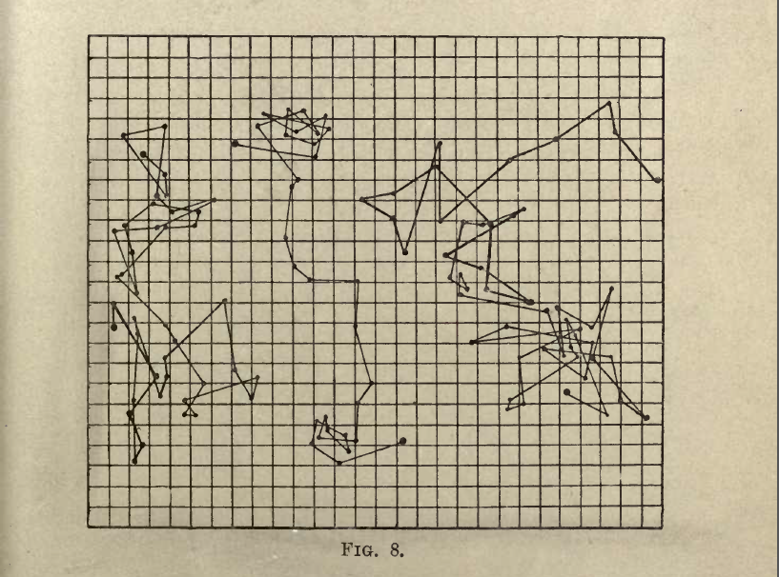

Measure displacement of particle in 2 D in a given time interval

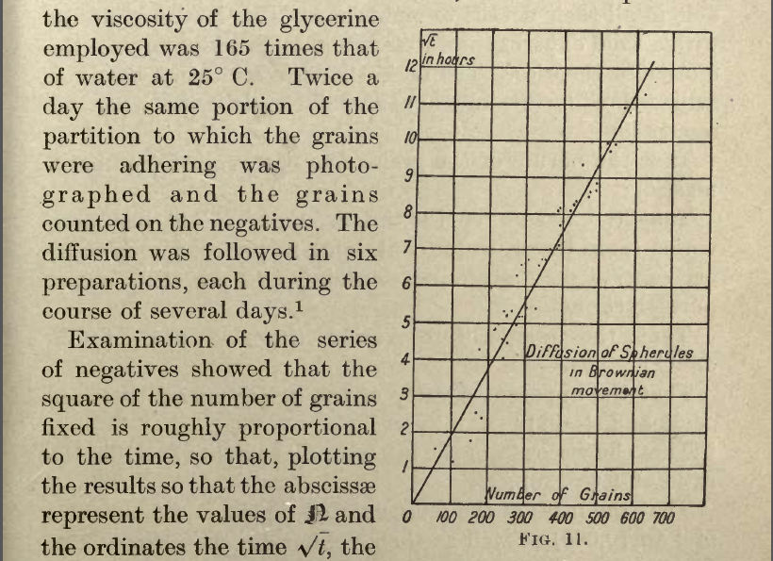

Number of diffused grains as function of $\sqrt{t}$

(Number of diffused grains ~ mean displacement)

5. Other evidence for atomic hypothesis

Estimates of N by a variety of means

N

Viscosity of gases 60 x 10²²

Brownian motion (displacement) 72 x 10²²

Brownian motion (rotation) 65 x 10²²

Diffusion of solutes (40-90) x 10²²

Mobility of ions in solution (60-150) x 10²²

Brightness of blue in the sky (30-150) x 10²²

Measurement of atomic charge (60-90) x 10²²

Emission of alpha particles (70) x 10²²

Black body radiation (60-80) x 10²²

Covergence: suggests real phenomeonon

Atomic hypothesis accepted

Most probable value for N (71) x 10²²

Most probable value for molecular magnitude (2.8) x 10⁻⁸ cm

II Early particles

1.Cathode rays and the electron

(http://boomeria.org/physicslectures/secondsemester/nuclear/nuclear1/nuclear1.html)

Study of the passage of electricity through gases

discharge tubes

electrodes at opposite ends of sealed tube
pressure reduced by pump system
E-field established between electrodes
rays travel great distances, tube glows green

William Crookes (1879): Crookes’s discharge tube

Observed: rays emitted at cathode (see shadow exps)
attracted by +ve charges, repelled by –ve
deflected by magnetic field

Deduced: cathode rays are negatively charged

Jean Perrin (1895): Paddle wheel discharge tube

cathode rays push wheels
→ rays have mass and velocity
→ must be particles

negatively charged
named electrons

J.J. Thompson (1897): ratio of charge to mass of electron

deflect electron beam using E- field

y_{E} = 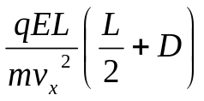

→ estimate q/m of electron if v_{x} known

Using B-field to balance E-field

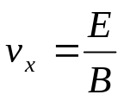 (since 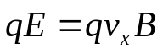)

calculate q/m = 1.76 x 10¹¹ C/g
R.A.Milikan (1909-11): measured charge of electron

1.charge oil drop by rubbing against nozzle of atomizer
2. experiences upward force qE due to applied E-field
3. balance against gravity

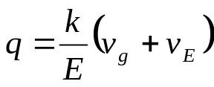

v_{g}: terminal velocity of gravity fall (measure by timing drop)
v_{E}: terminal velocity of rise (depends on q: measure series of v_{E})

experiment with many different charges on drop
set of values for v_{E} , q
all integer multiples of one value

q_{e} = 1.6 x 10⁻¹⁹ C

mass of the electron

since q/m_{e} = 1.76 x 10¹¹ C/kg (Thomson)

and q_{e} = 1.6 x 10⁻¹⁹ C (Millikan)

deduce m_{e} = 9.1 x 10⁻³¹ C/kg
2.Canal rays and the proton

Thomson (~1890):

- does anode produce +ve rays?

- +ve rays detected when slit put in cathode

- measure q/m ratio of +ve rays using Thomson method

Results
- v_{x} much smaller than electron case

- q/m much smaller than electron case

- q/m depends on gas in tube

- largest q/m value for hydrogen

- other gases have q/m simple fractions of H value

Deduce
- +ve particles (ions) due to e collision with gas atoms

- charge equal and opposite to electron

- mass much larger than electron (from q/m)

- H ion is lightest (named proton)

- all other ion masses multiples of m_{p}

proton charge = e⁺

proton mass = 1836 x m_{e} from q/m

III The nuclear atom

1. The plum pudding model

J.J.Thomson (1897-1900):
first quantitative measurements of electron
first quantitative measurements of proton

Thomson atomic model:
atom is a heavy sphere of massive +ve charges
seasoned with light electrons of –ve charge

plum pudding
electrically neutral

2. Rutherford’s nuclear atom

Ernest Rutherford (1911-13):

studied α-particles emitted by radium
studied how α-particles absorbed by matter

Experiment: bombard gold foil with α-particles

Results

  - many α-particles undeflected

  - many α-particles deflected by very small amounts

  - a few α-particles deflected by angles > 90º

  - a few α-particles deflected bounced back

Rutherford backscattering (RBS)

Conclude

+ve charge of atom concentrated at tiny core

mass of atom concentrated at tiny core

rest of atom almost empty

Analysis

nuclear radius ~ 10⁻¹⁴ m

nuclear density ~ 10¹⁷ kg/m³

Problem with nuclear model: what holds protons together in nucleus?
where are the electrons?
what gives solids their structure?

3. Atomic spectra

light emitted from excited gas comprises a discrete line spectrum
each element has its own characteristic spectrum

Hydrogen spectrum: described exactly by Rydberg-Ritz formula

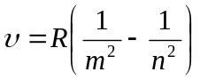

empirical formula

is spectrum due to atomic electrons?

Niels Bohr (1915): atomic spectra due to atomic electrons

- electrons occupy certain energy states outside of nucleus
- radiation emitted when electron jumps from one energy state to another

derived Rydberg-Ritz formula

Classical quantum theory: Hydrogen spectrum explained

Snag: other spectra unexplained

IV Nuclear physics

1.Transmutation of the elements

Rutherford (1919):

Experiment
α-particle bombardment of nitrogen gas

hydrogen ions (protons) produced

in some cases E_{p} > E_{α}

Results
α-particle absorbed by N nucleus

p⁺ then emitted by nucleus

similar results with other light elements

transmutation of the elements

Inference

1. nucleus has inner structure

2. charge_{nuc} carried by protons?

3. since mass_{nuc} > m_{p} for atoms above H

another nuclear particle with mass but no charge?
2. Discovery of the neutron

Joliot-Curies : α-particle bombardment of Be gas
produces neutral radiation (X-rays?)

James Chadwick (1932): neutral radiation = neutron particles?

Detection problems no ionisation
no cloud chamber track
no photographic image

the invisible man

Solution: elastic collisions with protons?

Experiment α-particle bombardment of B gas
products bombard paraffin wax behind target

Results protons knocked out of paraffin

Inference 1. En transferred to protons by massive particle

2. m_{n} ≈ m_{p} (from proton tracks)

a 2nd nuclear particle with proton mass but no charge

P.S. 1932: complete atomic model

nucleus contains protons and neutrons
electrons orbit atomic nucleus
explains atomic structure, isotopes, radioactivity

e.g. 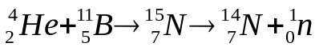

3. Radioactivity

Becquerel (1896): element uranium producing mysterious radiation that could penetrate black paper and fog photographic film
- independent of temp, press, E-field

Rutherford (1900): Becquerel radiation contains 3 components
α,β and γ rays

α rays: massive particles of double +ve charge
β rays: same q/m as electrons
γ rays: similar to X-rays, but higher energy and penetration

Rutherford and Soddy (1903):

some atoms can spontaneously disintegrate

- produce new atoms

- transmutation of the elements

→ - inner structure?

Pierre and Marie Curie (1906):

discovered new elements that produced similar radiation

radium
polonium

suggested radioactivity was a fundamental property of atoms

Neutron explanation for isotopes:

- nucleus of a given element contains given number of protons
- may have different numbers of neutrons
- identical no. of electrons
- identical chemical properties

e.g. ⁹²U₂₃₅ and ⁹²U₂₃₈

- explains isotopes

-explains uneven atomic masses

Neutron explanation for radioactivity:

α decay: 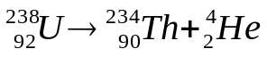

β decay: nº → p⁺ + e⁻ ?

snag: En and momentum missing, spin missing

Wolfgang Pauli (1936): postulates neutrino

massless, chargeless particle (detected in 1956)

nº → p⁺ + e⁻ + ν

- Splitting the ‘atom’

1932: Cockcroft and Walton (Rutherford group, Cambridge)

Experiment

Linear accelerator: protons accelerated in electric field to 1 MeV

Fired at Lithium atoms: alpha particles detected on zinc screens

Explanation

Li atoms split into 2 helium nuclei

First transmutation of elements by artificial means

Verification of E = mc² (Einstein)

Verification of quantum tunnelling (Gamow)

Nobel Prize (1951)
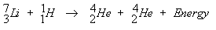

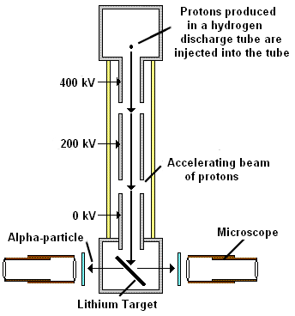
5. Nuclear fission

Rutherford, Fermi, Joliot-Curie, Hahn/Meitner: New element if U bombarded with neutrons?

Fermi: Large energy released + unidentified products: Els 93 and 94?
Joliot-Curie; Lathanam (57) detected in products
Hahn and Strassman (1938): Barium (56) detected in products

Lisa Meitner and Robert Frisch (1939): U nucleus is splitting in two; agrees with Bohr/Gamow ‘liquid drop’ model of nucleus

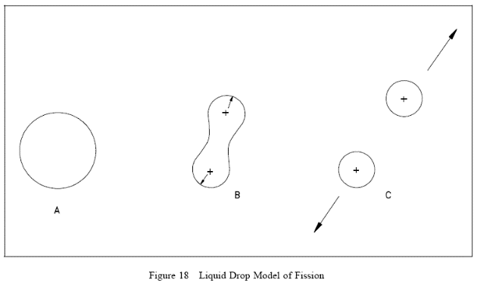

Fermi, Anderson (USA, Jan, 1939): only U 235 is undergoing fission

Joliot-Curie: 2-3 neutrons released per reaction (France, April, 1939)

Leo Szilard: possibility of chain reaction?

Energy released E = mc² ; nuclear reactors as energy source?

Chadwick (UK), Oppenheimer (USA): nuclear bomb? (1939)

Large amounts of uranium required: Ames process (USA)

Manhattan project (1943-45)

P.S. Element 93 made in 1940 (high-intensity neutrons)
6. Nuclear fusion

F.W. Aston (1919): precise measurements of atomic masses

Mass of He atoms less than four protons? Energy released by fusion?

Eddington (1920): Source of energy in the stars?

Gamow (1928): Gamow factor (QM)
Prob of binging two nuclei close enough for SF to overcome EM

Atkinson and Houtermans (1929) : measured masses of low mass elements suggest large energy could be released

E = mc²

Oliphant (1932): Tritium, Helium 3 and interactions

Bethe (1939): Model suggest how fusion powers the stars

- ‘Hydrogen burning’

Two protons fuse to form deuterium nucleus, chain reaction to He4
(figure 1)

- C-N-O cycle

Catalytic cycle involvng nuclei of carbon, nitrogen and oxygen
produces He nucleus (figure 2)

Problem: synthesis of elements between Carbon and Iron?

Answer: Hoyle (1954)
Burbidge, Burbidge, Fowler, Hoyle (1957)

V Cosmic rays, the weak force and the strong force

1. Cosmic rays

At first thought to be coming from radioactive elements in earth’s crust

Victor Hess: radiation increases with height (balloon exps)

Nature: fast-travelling ions of various elements

Source: Extragalactic?

The positron

Carl Anderson (1932): discovery of the positron

Same, mass, spin of electron: opposite charge

Deflection of particle in magnetic field in cloud chamber

Predicted by Dirac’s eq: antimatter

(anti-protons discovered in 1955)

- The neutrino and the weak force

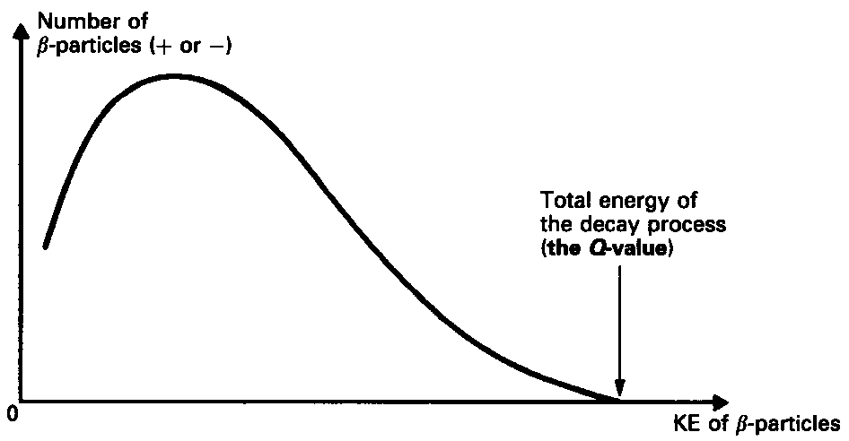

Spectrum of energy for emitted electrons

Most electrons ‘missing’ energy

Not accompanied by a photon

Energy not conserved?

Ang momentum not conserved?

e.g. ₁H³ → ₂He³ + e

or nº → p⁺ + e⁻

Wolfgang Pauli (1931): particle missing

Chargeless (charge conservation)

Massless or very small mass (some B particles of large energy)

3. Enrico Fermi (1934): Theory of the weak force

In addition to strong force

There exists a force that converts neutrons to protons and vv

Electron and additional particle emitted

Massless, chargeless, spin 1/2

Related to half-life of the nucleus

Named neutrino

Exp detected in 1956 by Cowan and Reines

Large flux of neutrinos in products of nuclear reactor

Detect by interaction

Since nº → p + e⁻ + ν

then ν + p → n + e⁺

Detect anti-neutrinos by simultaneous gamma photons

Today: neutrino factories (particle accelerators)

neutrino observatories (see below)

neutrino mass (see below)

neutrino oscillation (see below)

4. Yukawa (1935): Theory of the strong force

(i) Strong force must exist due to electrostatic repulsion of protons

Neutrons provide only partial shielding

Short-range force (10⁻¹⁵ m)

F_{S} = F_{C} x short-range factor

Strong force mediated by new massive particles: mesons

(ii) Mass of particles - from wave mechanics

Wave eq for nuclear force

Apply Panck’s eq E = hf

de Broglie’s eq p= h/λ

Solution : particle of mass m = hc/2πr_{o}

(iii) Mass of particles - from Heisenberg Uncertainty Principle

Solution : particle of mass m = hc/2πr_{o}

- Discovery of muons and pions (cosmic rays)

(i) 1933-36: Heavy electrons in cloud chambers (Anderson and Neddermayer, Street and Stevenson)

Mass = 100 MeV: Yukawa mesons?

Snag: no great reaction with nuclei
flux (sea-level) ~ flux (mountain-top)

not Yukawa particles: now known as muons
see Conversi, Pancini and Piccioni (1947)

Note: muon = very similar to electron but deflected less in B-field
member of lepton family

(ii) New search for the pi meson

C.E. Powell (1947): (suggested by Heitler)

Unmanned balloon experiments in upper atmosphere

Analysis of particle tracks in photographic emulsion

New heavy particle decays into two bodies, muon and electron

Yukawa’s particle

π → μ + e + ν

Analysis of Pi mesons (Kemmer):

Similar force between neutron-proton, neutron-neutron, proton-protron

3 pi mesons, neutral and charged, similar masses

All found eventually

Note: pi-meson not at all similar to electron or muon
Not member of lepton family
Member of meson family
Pion decay (Powell et al)

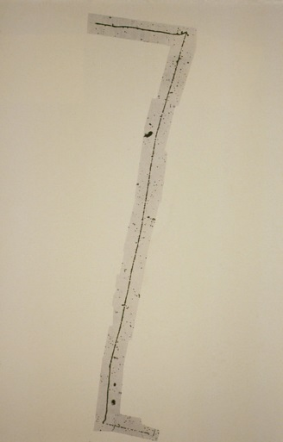

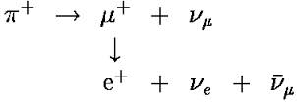

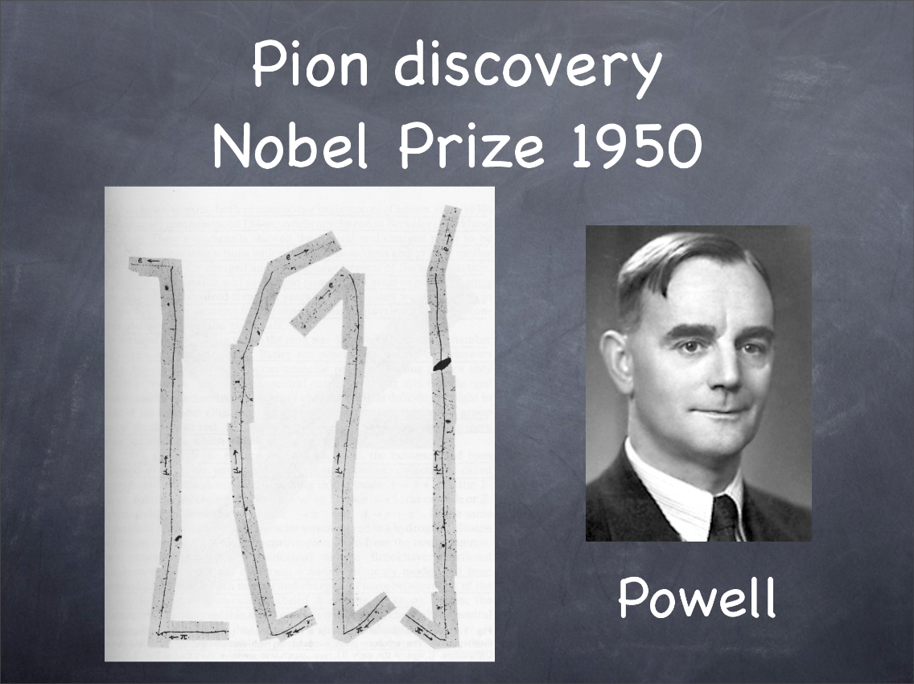

Mesons and hyperons

1930s: Proton, neutron, electron, neutrino (?)

1940s: Mesons (middle-mass): muon, pion (106 MeV/c² : 140 MeV/c²)

1947: New mesons (emulsion tracks)

Named V particles (Manchester University)

1952: Later named K mesons : K⁺, K⁻ and K⁰ (500 MeV/c²)

1953: Hyperons: more ‘mesons’ , heavier than nucleons

Named Ʌ, Σ, Ξ

Strangeness

Kaons, hyperons always produced in pairs

Produced in strong interactions: but slow decay

→ some new quantum property conserved?

conserved in strong interactions

violated in weak interactions

Strangeness → strange particles

1958-62: Resonances

Extremely short-lived particles
Existence deduced from decay products

definite masses: definite spins
named ‘resonances’

Are resonances excited states of particles?
Detectors

Wilson cloud chamber (1920s onwards)

Glass chamber filled with saturated vapour

Lower pressure by extending volume (piston)

Incident charged particle ionizes gas molecules

Ions in moist cooled air act as nuclei for clouds

Observe particle tracks as small clouds

Tracks photographed

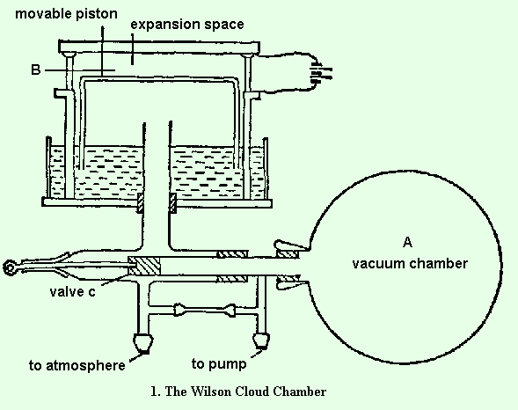

Nuclear Emulsions (1940s onward)

Incident charged particle ionizes particles of emulsion

Measured as tracks in emulsion
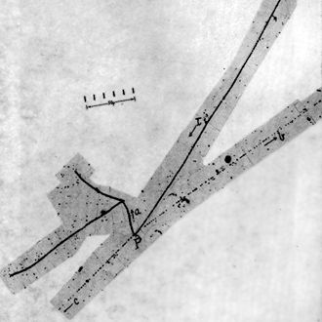

Bubble chamber (1950s onwards)

Glass chamber filled with superheated liquid

Lower pressure by extending volume (piston)

Incident charged particle ionizes liquid molecules

Observe particle tracks as bubbles in liquid

Tracks photographed

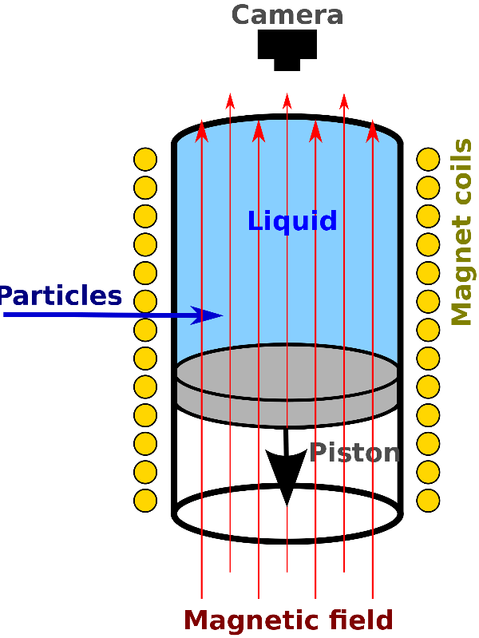
VI Accelerators and the Particle Zoo (1940-50s)

- Accelerators: from hunters to farmers

1932: Cockcroft and Walton (Rutherford group, Cambridge)

Linear accelerator: protons accelerated in electric field to 1 MeV

Fired at Lithium atoms: split into 2 helium nuclei

Transmutation of elements by artificial means

Verification of E = mc² (Einstein)

Verification of quantum tunnelling (Gamow)

Nobel Prize (1951)

1930: Ernest Lawrence: circular accelerator

Cyclotron: particles move in circular path due to B-field

Velocity increased with E-field

Particles accelerated to much higher energy than linear accelerator

Nobel Prize (1955)

Modern particle accelerators

LINACS

Acceleration through tube with alternating voltages

Electrons or protons

Synchrotrons

Initial acceleration in LINAC

Acceleration in one direction in first D

Reversed polarity in other D

Pulsed in accordance with relativity

Large radius due to radiation loss

Storage rings

Synchrotons operating as colliders

Head-on collision of particles

Higher fraction of K.E. converted into new particles

VII The quark model of particle physics

(i) The eightfold way

Hundreds of new particles

Similar to hundreds of new elements

Periodic Table: repeated patterns
→ elements are composed of atoms (protons etc)

Does a similar pattern exist for elementary particles?

Gellmann (1961): arranged particles into patterns using group theory

The eightfold way

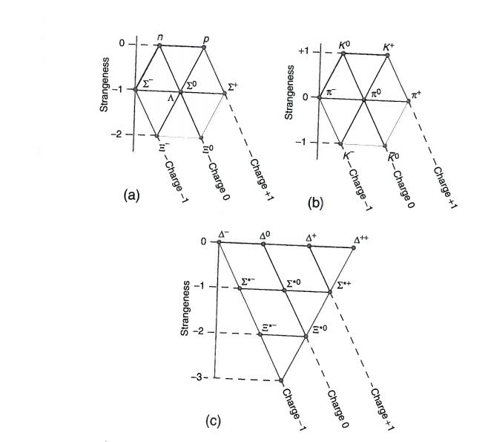

Predicts new particle (Ω⁻): S = -3: Q = -1: mass =1680 MeV/c²

Detected 1963

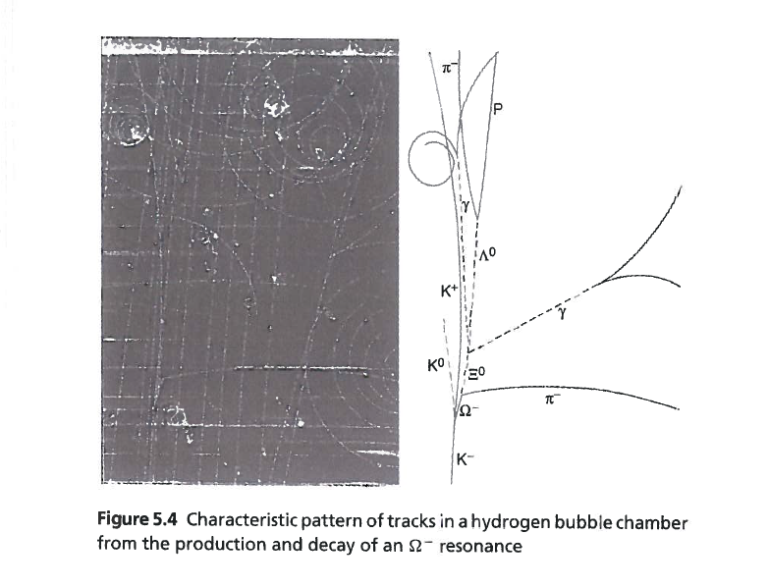

(ii) The quark model

Gellmann and Zweig (1964): particles contain more fundamental units?

quarks: up, down strange
fractional charges Q S

u 2/3 0
d -1/3 0
s -1/3 -1

Quark model: meson = quark-antiquark pair
hadron = 3 quarks (p = uud, n = udd, Ω⁻ = sss )

All hadrons, resonances and stable particles made of quarks

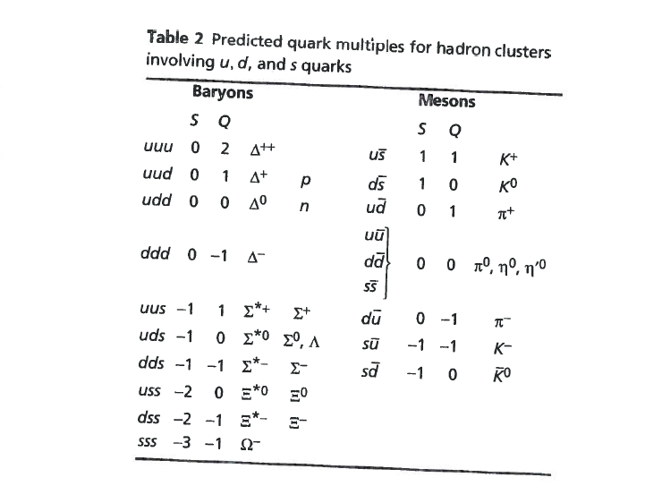

Skepticism concerning quark model

1. No observations of free quarks
2. Postulation of fractional charges
3. Violation of Pauli exclusion?
(iii) The search for quarks

a) Collisions between hadrons liberate quarks?

Never observed

Extraction from hadron impossible?
not enough energy
or
not possible in principle?

Inter-quark force increases with increasing distance?
Hypothesis: bound states

If enough energy supplied, create quark-antiquark pair (meson)

b) Search for bound states

SLAC 1969: evidence of internal structure of proton

electron scattering experiments
most electrons passed unimpeded
small number scattered through large angles

3 ‘nuclei’ inside proton

muon scattering, proton scattering

Result: 3 quarks inside proton (uud)

1970s: evidence for quark colour

Evidence for mesons containing quarks: ud, us, sd

Quark masses

Up, down quarks: 350 MeV/c²

Strange quark: 500 MeV/c²

(iv) Quark colour

p = uud? Ω⁻ = sss?

Identical spins (1/2) - fermions

Do quarks have identical quantum numbers? (Pauli exclusion not apply?)

Nambu and Hahn: quarks have extra quantum number

3 possible values – ‘colour’

Combination of red, yellow blue = white

All hadrons and mesons white

Force between quarks due to colour – quantum chromodynamics QCD

QCD: the interaction between quarks

Transmitted by particles called gluons

Zero mass, spin 1 (bosons)

Gluon has colour

Free gluons not detected: indirect evidence (1970)

Rate of muon production vs quark production

Note: Force between hadrons different from force between quarks
(v) Three new quarks: charm, beauty and truth

a) Glashow and Bjorken (1964): leptons and quarks fundamental

Also: electroweak theory: symmetry between quarks and leptons?

2 generations of leptons → 2 generations of quarks?

1970s: neutral weak currents: additional channel of disintegration?

New quark with new flavour? new quantum property?

November 1974: new hadronic resonance at SLAC, Brookhaven

New particle J/ψ : ‘long’ lifetime (1976 Nobel prize)

J/ψ = meson made of charm cc : new quark of mass 1500 MeV/c²
Charm: new quantum property
cc : charmonium

1976: SLAC and Berkeley: neutral charmed meson D⁰ (cu)
D⁺ and D⁻ later observed
Charm mesons with naked charm

b) 1975 Discovery of taon (heavy muon) 1777 MeV/ c²

3 generations of leptons → 3 generations of quarks?

1977 Fermilab: new heavy meson ϒ
too heavy to be made of known quarks
consists of pair of new quarks? (bb: beauty)
Beauty: new quantum property
bb: bottomium

new search for b- mesons (bu or bd pairs)
naked beauty

Discovered in Cornell storage ring in 1982; confirmation of b-quark

New quark of mass 4.5 GeV/c²

c) Truth quark: does beauty quark have a partner?

Discovered in 1995 (Tevatron, Fermilab): t → b + W⁺

W boson decays to quarks and anti-quarks (or to leptons)

Estimated mass of top quark: 180 GeV/c²

Extremely short lifetime;10⁻²⁵ s

Too short for clustering: no toponium
no hadrons with non-zero truth

Summ 6 quarks + 6 leptons: fundamental particles of matter

Further generations of quarks? Not expected

- Enormous mass (immeasurably short lifetimes)

- Three generations of leptons
Chap VIII The Electroweak Interaction

Recall

- Leptons and quarks

1960s – 1990s: discovery of quarks and heavy leptons

6 quarks (in 3 colours): affected by strong force
6 leptons: not affected by strong force

All have half-integer spin: fermions
Pauli exclusion principle applies

3 generations of quarks and leptons

1st generation: all of ordinary matter
2nd, 2rd generation; cosmic rays and accelerators

Note: lepton and quark numbers conserved in interactions

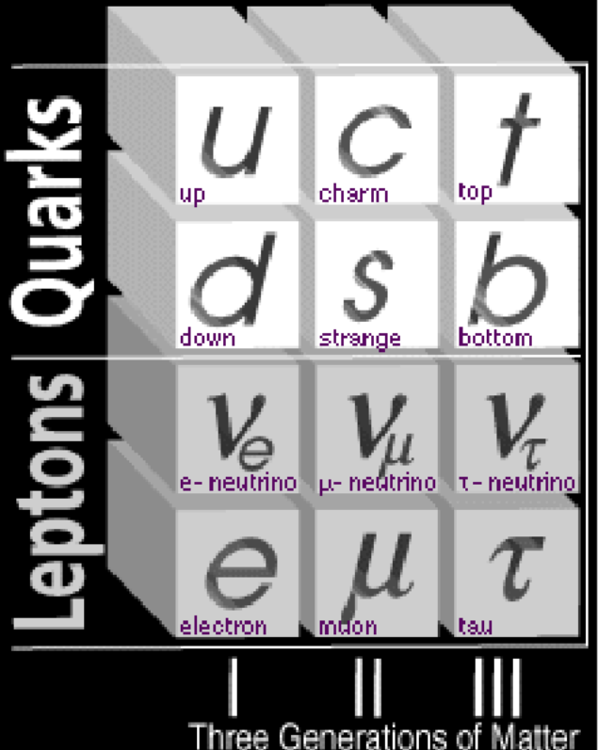

- The neutrino and the weak force

Spectrum of energy for emitted electrons

Most electrons ‘missing’ energy

Not accompanied by a photon

Energy not conserved?

Ang momentum not conserved?

e.g. nº → p⁺ + e⁻

Wolfgang Pauli (1931): particle missing

Chargeless (charge conservation)

Massless or very small mass (some B particles of large energy)

Enrico Fermi (1934): Theory of the weak force

In addition to strong force

There exists a force that converts neutrons to protons and vv

Electron and additional particle emitted

Massless, chargeless, spin 1/2

Related to half-life of the nucleus

Named neutrino

Exp detected in 1956 by Cowan and Reines

Large flux of neutrinos in products of nuclear reactor

Detect by interaction

Since nº → p + e⁻ + ν

then ν + p → n + e⁺

Detect anti-neutrinos by simultaneous gamma photons

Today: neutrino factories (particle accelerators)

neutrino observatories (see below)

neutrino mass (see below)

neutrino oscillation (see below)

The Weak Interaction

1950s: quantum electrodynamics

Weak interaction proceeds via exchange of heavy, charged bosons

Lee, Rosenbluth and Yang: Weak boson W⁺, W⁻

‘Messenger’ role similar to photon (em)

Thus nº → p + e⁻ + ν_{e} ( β-decay )

is really nº → W⁻ → p + e⁻ + ν_{e}

Also μ⁻ → e⁻ + ν_{e} + ν_{μ}

becomes μ⁻ → W⁻ → e⁻ + ν_{e} + ν_{μ}

-
Also τ⁻ → e⁻ + ν_{e} + ν_{τ}

becomes τ⁻ → W⁻ → e⁻ + ν_{e} + ν_{τ}

Weak charged interaction: coupling constant α_{w}

Similar to coupling constant of em interaction α

But weak interaction much feebler: suppressed by mass of W boson

W ~ 78 GeV/c²

Quark decay via weak charged interaction

Pion decay

π ⁻ → μ⁻ + υ_{μ}

is really
(du) → W⁻ → μ⁻ + υ_{μ}

Quark number conserved
Lepton number conserved

Prediction of neutral weak interaction

Sheldon, Glashow and Weinberg (1968): gauge theory
Extra ‘exchange’ particle Z⁰ necessary to avoid infinities

W⁺, W⁻, Z⁰

Coupling constant α_{z} similar to α_{w}

Extremely heavy particles: integer spin (bosons)
3. Electroweak interaction

Glashow, Salam, Weinberg (1968):
Exchanged photons necessary to avoid infinities in weak interactions

Relation between weak and electromagnetic interaction?
Weak interaction ‘weak’ because of mass of W
α, α_{z} and α_{w} all related

Electro-weak interaction

Above 200 GeV, electromagnetic and weak interaction identical
Unification condition: weak mixing angle: θ_{w} = m_{w}/m_{z}

Problem: predicts massless particles

True for photon, not true for Z, W⁺, W⁻

Solution: breaking of electroweak symmetry below 200 GeV
Spontaneous symmetry breaking

Mechanism: new scalar field with non-zero value in vacuum state
Higgs field (1964)

Interaction with Higgs field gives W and Z bosons mass

Predictions;

1.Interaction with Higgs field gives masses W⁺⁻ and Z⁰ bosons
Determines mixing angle θ_{w}

2. Interaction with Higgs field gives masses to all the quarks and leptons

3. Particle associated with Higgs field must exist
Higgs boson

4. Experiments

Weak neutral currents (CERN 1973)

Quark or lepton absorbs neutral Z boson

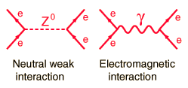

Signature : electron knocked into motion by the punch of unseen projectile (+ hadronic events)

Detection of W and Z bosons (CERN, 1983)

W⁻ → e⁻ + ν_{e} (UA1: 5 events: January)

W⁺ → e⁺ + ν_{e} (UA2: confirmed a few weeks later)

Z⁰ → e⁺ + e⁻ (UA1: one event: April)

Z⁰ → e⁺ + e⁻ (UA2: confirmed a few weeks later)

Chap IX The Standard Model

1. Leptons and quarks

1960s – 1990s: discovery of quarks and heavy leptons

6 quarks (in 3 colours): affected by strong force
6 leptons: not affected by strong force

All have half-integer spin: fermions
Pauli exclusion principle applies

3 generations of quarks and leptons

1st generation: all of ordinary matter
2nd, 2rd generation; cosmic rays and accelerators

Note: lepton and quark numbers conserved in interactions

- Quark model: quantum chromodynamics

- Lepton model; electroweak interaction

Glashow, Salam, Weinberg (1968):
Exchanged photons necessary to avoid infinities in weak interactions

Relation between weak and electromagnetic interaction?
Weak interaction ‘weak’ because of mass of W
α, α_{z} and α_{w} all related

Electro-weak interaction

Above 200 GeV, electromagnetic and weak interaction identical
Unification condition: weak mixing angle: θ_{w} = m_{w}/m_{z}

Problem: predicts massless particles

True for photon, not true for Z, W⁺, W⁻

Solution: breaking of electroweak symmetry below 200 GeV
Spontaneous symmetry breaking

Mechanism: new scalar field with non-zero value in vacuum state
Higgs field (1964)

Interaction with Higgs field gives W and Z bosons mass

Predictions;

1.Interaction with Higgs field gives masses W⁺⁻ and Z⁰ bosons
Determines mixing angle θ_{w}

2. Interaction with Higgs field gives masses to all the quarks and leptons

3. Particle associated with Higgs field must exist
Higgs boson

4. Standard Model: summary

Combines electro-weak theory, QCD, quarks and leptons

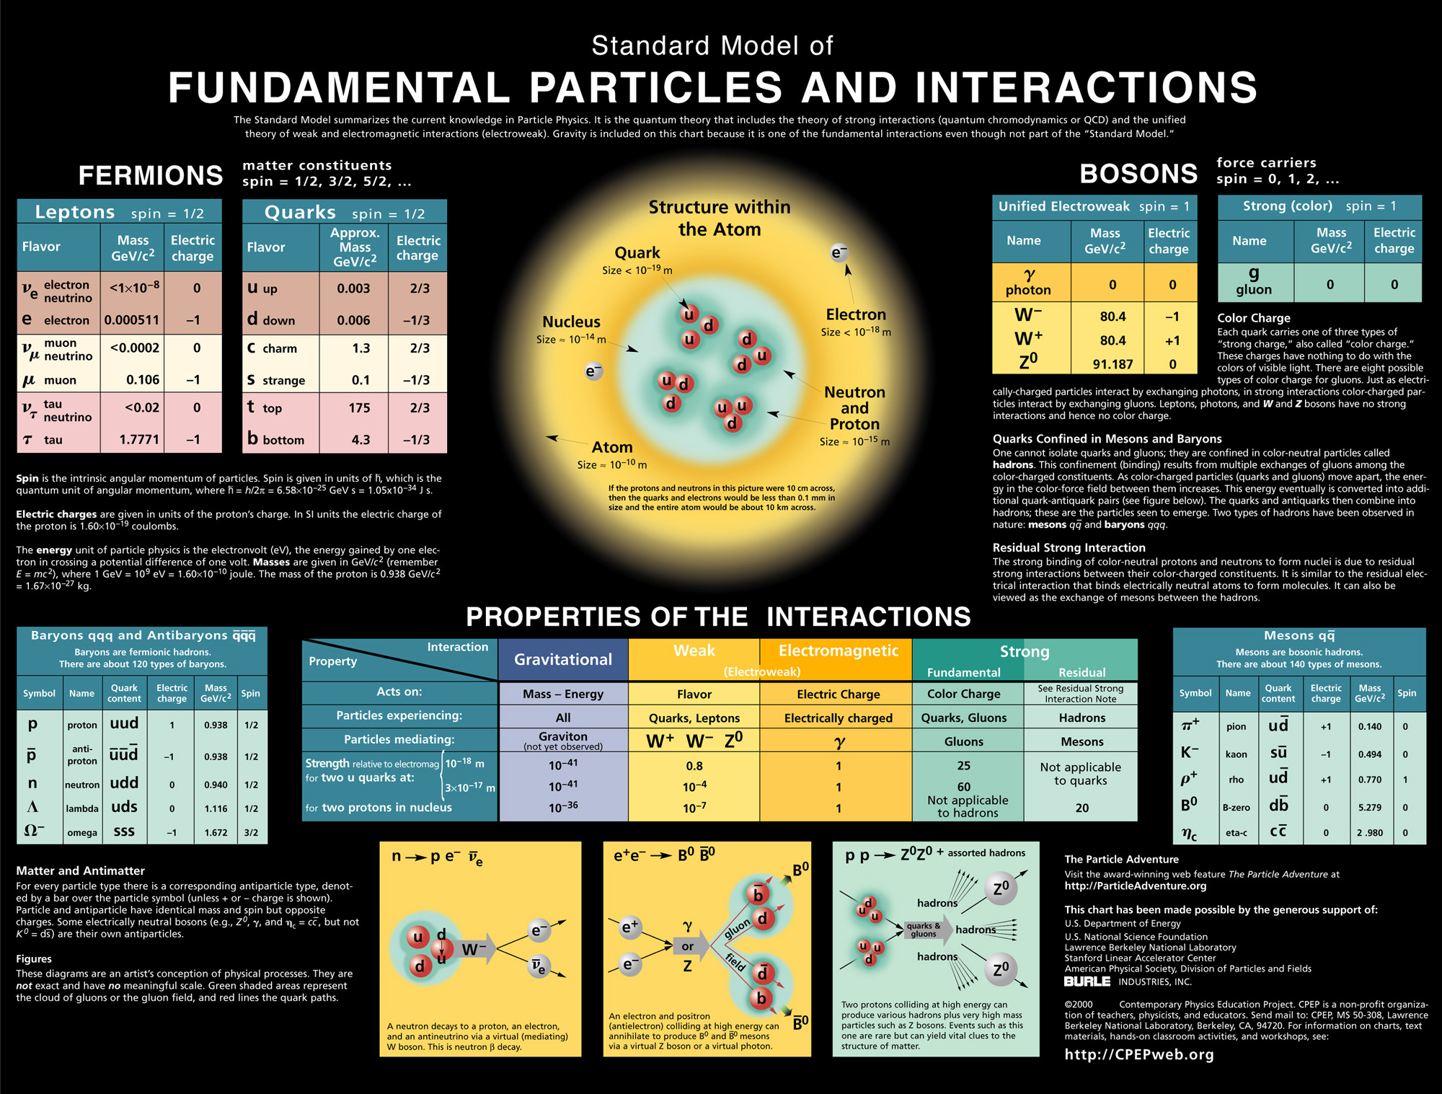
5. Limitations of the standard model

What is the mass of Higgs boson?

Why do other particles have the masses they do?
(t quark = 180 GeV/c², b quark 5 Gev/c² !)

Why are there 3 different generations of quarks and leptons?

Why do the fundamental interactions have different strengths?

Is there a connection between electro-weak and QCD?

Is there a connection between electro-weak, QCD and gravity?

X The search for the Higgs boson

- Electro-weak symmetry breaking
- Mediated by scalar field: Higgs field
- Generates mass for W, Z bosons

W and Z bosons (CERN, 1983)

- Generates mass for all massive particles
- Associated particle: Higgs boson

Particle masses not specified

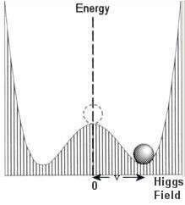

- Particles acquire mass by interaction with the field

- Some particles don’t interact (massless)
Photons travel at the speed of light

- Heaviest particles interact most
Top quarks

- Self-interaction = Higgs boson
Higgs production

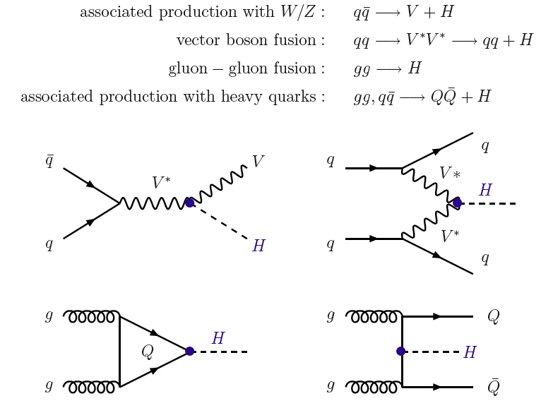

- Most particles interact with Higgs

- Variety of decay channels

- Massive particles more likely

- Difficult to detect from background

- Needle in a haystack

High luminosity required
Higgs decay channels

Most likely: H⁰ → Z⁰ Z⁰ → L⁺L⁻L⁺L⁻

H⁰ → γ γ

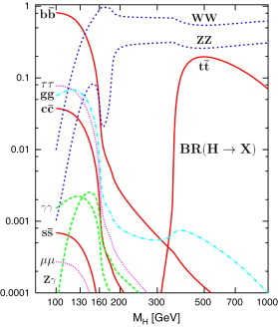

Depending on Higgs mass

RHS channels dominant if mass greater than 200 MeV

LHS channels dominant if mass less than 200 MeV
Higgs boson: results

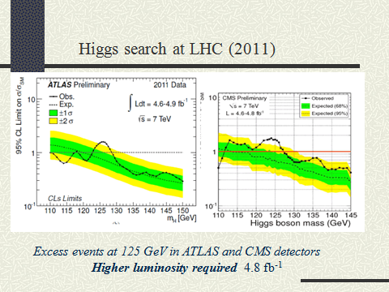

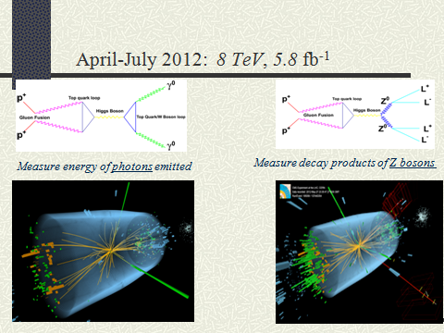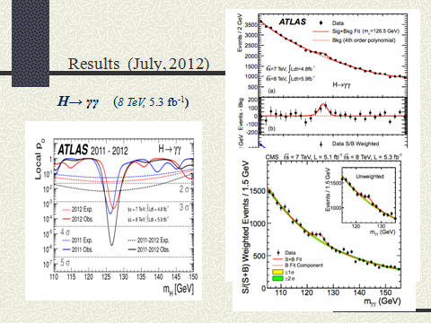

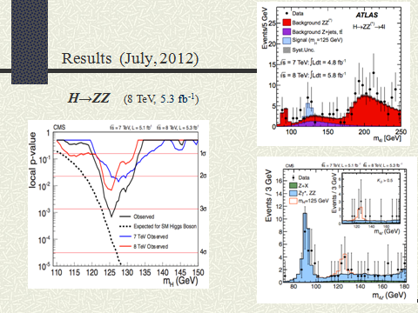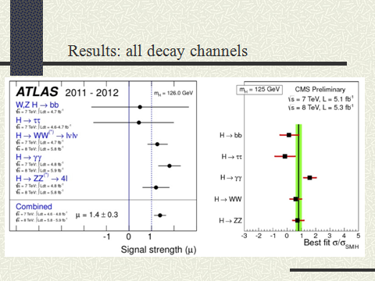

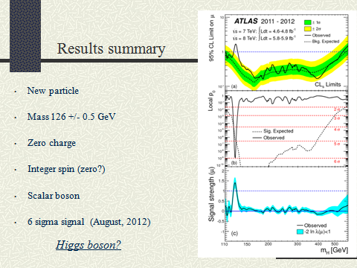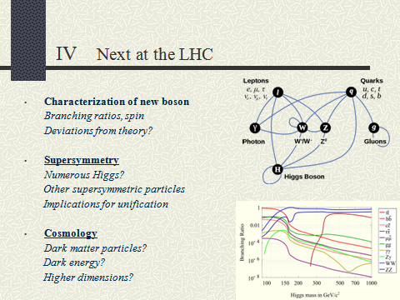

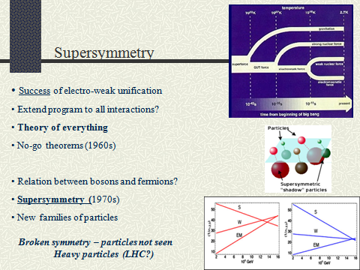
XI Beyond the standard model

1. Grand Unified Theories (GUT)

Theoretical attempts to unify the electroweak and strong interactions

Evidence:

- sum of electric charge for each generation = 0
- all charges multiples of e/3
- QCD strength = electroweak coupling for E = 10¹⁶ GeV

Tests:
- proton decay

- magnetic monopoles

Snag;

1st spontaneous symmetry breakdown at 100 Gev (w, em)
2nd spontaneous symmetry breakdown at 10¹⁶ GeV (e-w, st)

not compatible with QT

Theories of Everything

Attempts to incorporate gravity into unification scheme

Unified field theory of all 4 interactions
2. Super-symmetry (1971-73)

symmetry between quarks, leptons and force carriers?

i.e. symmetry between fermions and bosons ?

each fermion had a bosonic partner (squarks and sleptons)
each boson had a fermionic partner (photinos, gluions etc)

since these particles not observed

super-symmetry = broken symmetry

SUSY unification of electro-weak and QCD:

much better than GUT theoretically

- less infinities

- less renormalization

- more natural

-hints of role for gravity – supergravity

3. Super-gravity

attempts to unify all four fundamental interactions
Theories of Everything (ToE)

Kaluza (1921): ‘unified’ GR and electromagnetism
Wrote GR in 5 dimensions, em appears naturally

Klein (1927): converted Kaluza theory to quantum field theory

Einstein; attemoted to generalize

Snag: no new predictions, no evidence

Today: super-gravity

Super-symmetric version of GR

SUSY-GUT with gravity incorporated

Snag; not a quantum field theory
(better than GR)

3. Superstring theory

- string theory

Veneziano (1968): solution to ‘bootstrap’ model of the hadrons

Nambu, Susskind: Veneziano solutions are excitations of a string

- quarks and leptons are small vibrating strings
(not point-like particles)

string theory of the hadrons

- intoduce multi-dimensions to avoid infinities etc

- string theory and gravity

early string theory predicted new particle
mass = 0, spin = 2

Schwarz and Scherk (1981): particle = graviton!
Re-interpret string theory as theory of gravity

- superstrings

Green and Schwarz (1981): combine strings and supergravity
superstrings

Green and Schwarz (1984):
- finite theory of quantum gravity
- encompasses standard model and gravity

Gross (1984): perfected 10-dimensional superstring theory
successful Theory of Everything?

Snag: how to reduce to 4 dimensions
compactization not unique
arbitrary parameters
much too flexible
no definite predictions

4. Evidence for physics beyond standard model

(i) intersection of 4 interactions

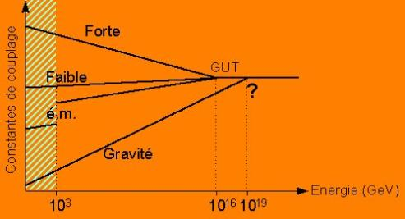

(ii) super-symmetric particles

Hints of SUSY-Higgs at Tevatron? (New Scientist, 2007)

SUSY particles at LHC? (2008)
Epilogue

- Unified field theory and the Big Bang

Electroweak unification expected at 10² GeV

Electorweak + strong unification expected at 10¹⁶ GeV

Electroweak, strong+ gravity unification expected at 10¹⁹ GeV

Snag: E > 10³ GeV not attainable in modern accelerators

Soln: study of remnants of Big Bang

particle physics → cosmology

- Standard model of cosmology

Time Temp Energy (GeV) Epoch

10⁻⁴³ s 10³² K 10¹⁹ GeV superforce

10⁻³⁷ s 10²⁹ K 10¹⁶ GeV strong, electroweak decouple

10⁻⁹ s 10¹⁵ K 10² GeV weak, e-m decouple

10⁻² s 10¹³ K 1 GeV quarks→hadrons

100 s 10⁹ K 10⁻⁴ GeV nucleosynthesis

10⁶ y 10³ K 10⁻1 eV photons decouple

10¹⁰ y 3 K 10⁻³ eV galaxies today

Q: How did matter (quarks) get created?

Ans: Creation of quark-anti-quark pairs during BB

Asymmetrical decay: excess matter remains

Aided by inflation

2. Inflation

Alan Guth (1981): hyper-expansion after BB

Phase change predicted by particle physics

Expansion rate later slowed

Evidence for inflation:

flatness problem

horizon problem

galaxy formation

cosmic background radiation

Inflation and creation of U:

(i) quark-antiquark pair created from quantum vacuum

(ii) inflated to U size

U = free lunch!

